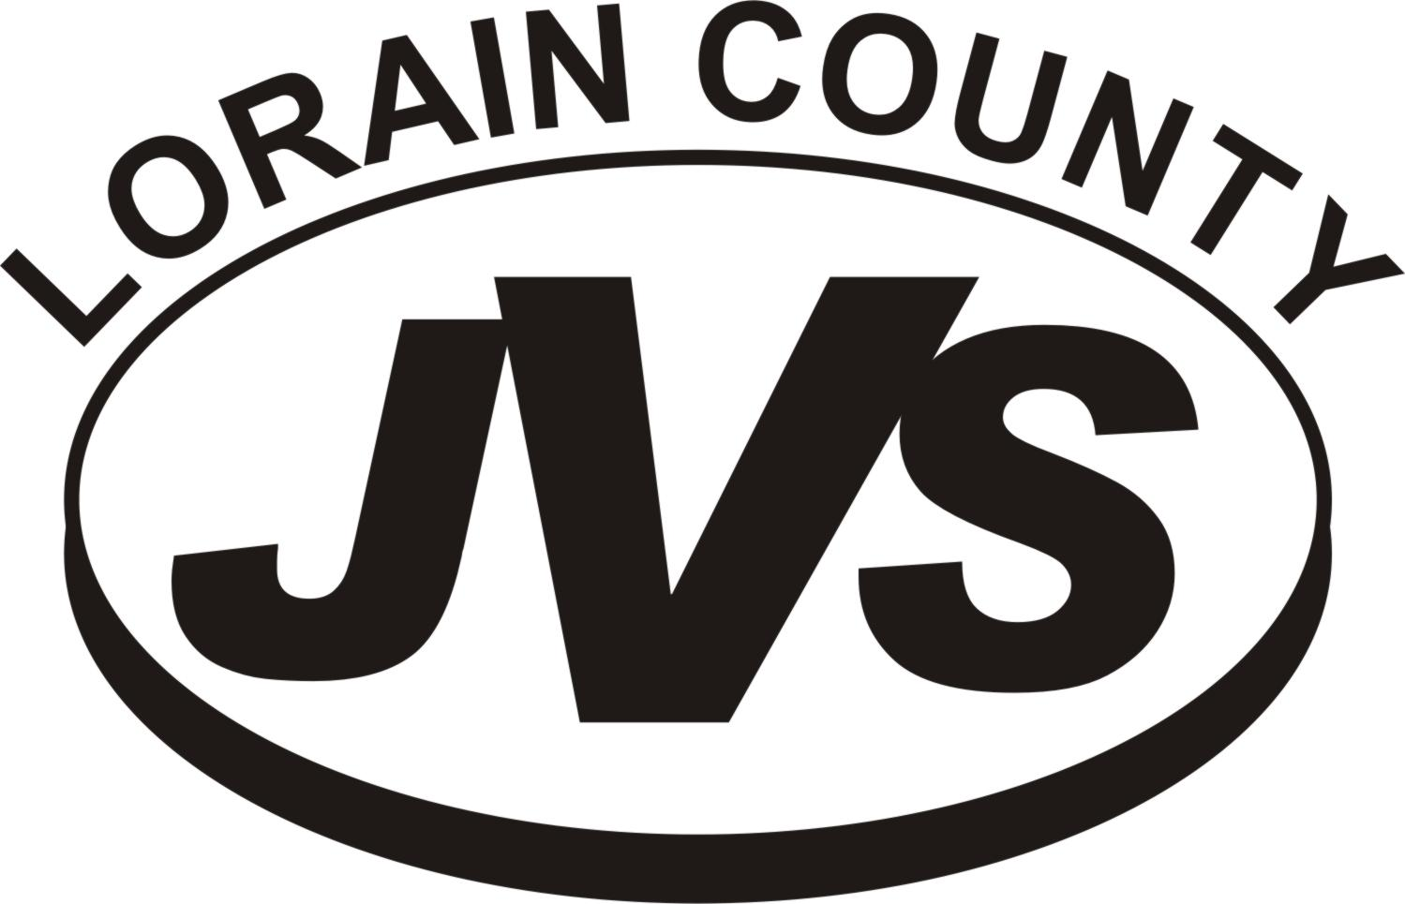NATIONAL TECHNICAL HONOR SOCIETY

LORAIN COUNTY JVS CHAPTER

NEW MEMBER

APPLICATION REQUIREMENTS

You may be eligible for membership in the Lorain County JVS National Technical Honor Society (NTHS). Your selection will NOT be final unless you meet all eligibility requirements, turn in the items in this packet by the due date, and are accepted by the NTHS selection committee for membership.

What you need to do . . . .

- Read the membership requirements. You must meet the grade point average (GPA), attendance, graduation, discipline and teacher recommendation requirements. You will need to verify your activities/service history, complete the other required forms, and meet the deadline for turning in the items in this packet.

- COMPLETELY fill out the application for membership. This includes attaining all signatures, a comprehensive resume and a letter of interest. Be sure to include both associate school and the JVS activities on the Activity/Service Record. Your teachers will be happy to help you fill out your application.

- Be certain to turn in your completed application no later than 2:30 P.M. ON FRIDAY, FEBRUARY 21, 2025. LATE FORMS WILL ELIMINATE YOU FROM FURTHER CONSIDERATION FOR MEMBERSHIP.

- New members will be announced at a Tapping Ceremony on Friday, April 4, 2025.

REMEMBER: LATE FORMS WILL ELIMINATE YOU FROM FURTHER CONSIDERATION FOR MEMBERSHIP. TURN THIS PACKET IN TO MS. WEST IN THE STUDENT SERVICES OFFICE BY 2:30 P.M. ON FRIDAY, FEBRUARY 21, 2025 OR EMAIL TO MWEST@LCJVS.NET.

Advisors: Ms. Berthold Extension 22377
Ms. Gleason Extension 22284
Mrs. Greer Extension 22451
Mrs. Pluta Extension 22498
Mrs. Potter Extension 22316
Ms. West Extension 22221

NATIONAL TECHNICAL HONOR SOCIETY
LORAIN COUNTY JVS CHAPTER

MEMBERSHIP REQUIREMENTS:

GPA: 3.5 GPA while enrolled as a junior and senior at the JVS. Tech Prep and
Half day students must include a printed copy of their 1st semester report card.

ATTENDANCE: Juniors: No more than 15.00 hours absent during the first semester at the JVS.
Seniors: No more than 50.00 hours absent during three semesters at the JVS.

Please explain any absence over 15 or 50 hours for first year students. The member should attach a letter of explanation for consideration.

GRADUATION REQUIREMENTS: Candidate must be on track to graduate.

DISCIPLINE: No disciplinary suspensions while at JVS; this also includes no associate school infractions.

SERVICE: Activities are considered that have been completed during grades 9 - 12. A JVS student demonstrates service by taking an active role in the program's Career-Technical Student Organization (BPA, DECA, Skills USA, FFA, FCCLA, HOSA), participating in other JVS organizations such as VYC, being employed, participating in service projects, participating in associate school activities and
by taking an active role in the community and/or church.

RECOMMENDATION: Teacher Recommendation Sheets must have a score of at least 80%. A minimum of two outside academic recommendations for Tech Prep/half day students.

DEADLINES: Candidates must meet all deadlines for submitting required forms.

FORMS: The student, parent/guardian and teachers must all sign the Intent to Participate form.

LETTER OF INTEREST ANDCOMPREHENSIVE RESUME:
New Candidates must submit a type-written comprehensive resume and a letter of interest as part of the application.
Please include/address any absences you have had during your time at Lorain County JVS.
Additional Letters of Recommendation will be considered by the committee throughout the selection process. Those students taking academic classes elsewhere are strongly required to submit additional recommendation letters.

TO REMAIN A MEMBER IN GOOD STANDING:

QUALIFICATIONS: All of the above qualifications must continue to be met.

SERVICE: Members must log fifty (50) hours of community service prior to the end of the first semester of your senior year. Members that have a total of one hundred (100) hours of community service will be eligible for a graduation stole.
PROJECT : Members must participate in a group project to be determined by the NTHS members.

STUDENT _______________________________ PROGRAM ____________

NATIONAL TECHNICAL HONOR SOCIETY
LORAIN COUNTY JVS CHAPTER

INTENT TO PARTICIPATE

You may be eligible for membership into the National Technical Honor Society. If you would like to be considered for the NTHS induction, please indicate your intent below.

_________ I would like to be considered for membership. I understand that this does not guarantee membership, only that I will be considered for the National Technical Honor Society. As a member of the National Technical Honor Society, I understand that I will be expected to be actively involved in Honor Society projects, maintain a 3.5 cumulative GPA at JVS, maintain excellent attendance and meet the hours of service requirement during my senior year.

_________ 3 Year Student

_________ 4 Year Student

ASSOCIATE SCHOOL _________________________

__________________________ ___________________________
Student Signature Parent/Guardian Signature

__________________________
Date

NATIONAL TECHNICAL HONOR SOCIETY
LORAIN COUNTY JVS CHAPTER

PHOTO/VIDEO CONSENT AND RELEASE

TO BE FURTHER CONSIDERED FOR NTHS MEMBERSHIP

THIS FORM MUST BE RETURNED TO MS. WEST IN THE STUDENT SERVICES OFFICE BY 2:30 P.M., ON FRIDAY, FEBRUARY 21, 2025 OR EMAIL TO MWEST@LCJVS.NET.
FAILURE TO MEET THIS DEADLINE WILL ELIMINATE YOU FROM FURTHER CONSIDERATION FOR MEMBERSHIP.

NATIONAL TECHNICAL HONOR SOCIETY
LORAIN COUNTY JVS CHAPTER

PHOTO/VIDEO CONSENT AND RELEASE

Please complete the first section of this form if you give your permission for your student to be photographed or videotaped as a part of the National Technical Honor Society. If you do not wish to have your student photographed or videotaped as a part of the National Technical Honor Society, please complete section two.

SECTION ONE

We, the undersigned (student and parent/guardian if a minor), hereby grant to the Lorain County JVS the right to use and publish photographs/videos of me, my image, likeness and/or quotes for the purpose of recognizing my induction into and participation in the Lorain County JVS Chapter of the National Technical Honor Society. This consent and release is only for those activities related to the National Technical Honor Society.

Additionally, we waive the right to inspect and/or approve the finished product and the use(s) to which it will be applied. Furthermore, we release the Lorain County JVS from any future liability or compensation claims associated with the use of said photographs/videos.

___________________________ _______________________________
Student Signature Parent/Guardian Signature

___________________________ ______________________________
Date Date

SECTION TWO

I do NOT give my permission for my student to be photographed or videotaped as a part of the National Technical Honor Society.

___________________________ _______________________________
Student Signature Parent/Guardian Signature

___________________________ ______________________________
Date Date

NATIONAL TECHNICAL HONOR SOCIETY
2025
INFORMATION SHEET

Name ______________________________________ Program ___________

Associate School _____________________ Phone __________________________

Email Address _________________________________________________________

The following information will be used to mail induction ceremony invitations to your parents or guardians. If your parents have separate addresses and you wish to invite them both, please complete the second set of address information.

Parent/Guardian Names
Street Address
City |  |  |  | Zip

Parent/Guardian Names
Street Address
City |  |  |  | Zip

SENIORS ONLY

I will not be attending college or technical school. My plans after graduation are
The college or technical school I am planning to attend is
My college major will be
My career plans five years from now include
The scholarships that I have received are

NAME ____ PROGRAM _________ HOME SCHOOL _____________

LORAIN COUNTY JVS NATIONAL TECHNICAL HONOR SOCIETY
EXTRA CURRICULAR/SERVICE/ EXPERIENCE ACTIVITY RECORD

The Extra Curricular Activity Record will be used in the selection of the National Technical Honor Society members. Please complete this form IN DETAIL…..if you were involved in ANYTHING. WRITE IT IN!!!! Please list any non-academic or academic activities, extra-curricular activity you have participated in. (sports, clubs and etc.) Please list your role in these clubs or activities. This can be school, community or service based. This is a critical part of becoming an Honor Society member.
* MUST BE RETURNED TO MS. WEST IN THE STUDENT SERVICES OFFICE BY 2:30 P.M., FRIDAY, FEBRUARY 11, 2022.

VOLUNTEER WORK  List and explain our involvement. Include the number of hours you contributed to each project. | 9 | 10 | 11 | 12

LETTER OF INTEREST AND COMPREHENSIVE RESUME MUST BE TYPED.

- Include a typed letter of interest introducing yourself and explaining why you feel that you would be an exemplary member of the National Technical Honor Society. Please include any extenuating circumstances relating to attendance.

- Include a typed comprehensive resume that paints a full picture of your abilities as a student and a professional.

